“Let food be thy medicine and medicine thy food.” ~ Hippocrates

We started 2026 with the “new food pyramid” and message of 'eat real food'. This is a great reminder that not only should our diet consist of real foods, but our supplements should too.

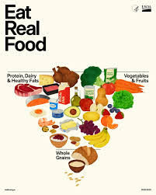
Nothing replaces high quality nutrition! But if you’re like me and you want to supplement your diet and aren’t sure what to take, I completely understand. I’ve been there too.

Did you know there’s a difference between high-quality and low-quality vitamins and supplements?
Does your doctor recommend both a good diet AND “real food” vitamins?
Most doctors don’t and some even believe vitamins don’t work, and they may be right – especially if the supplements in question are synthetic.

Synthetic sources are dangerous, toxic, and can cause many problems including death.
How are they made? What ingredients to they contain?
It’s important to determine whether your vitamins are made from real food or artificial imitations. Consider choosing 100% whole-food vitamins that are not sprayed, contain no additives, and are not derived from inorganic materials.

As far as I am aware, Doctors' Food Research is the only professional supplement company that labels its products as 100% Food. This guarantees there are
no synthetics, no chemicals, and no excipients (such as magnesium stearate).

Dr. Thiel, founder of Doctor’s Food Research, is a Naturopathic Doctor, Nutritional Scientist, and Food Researcher. He is the author of several books and numerous published articles and dedicated to education and healing. For more about him please see his website.
Quality matters! Learning the difference can help you achieve better health outcomes and avoid wasting time and money on products that have no benefit and may even harm you.

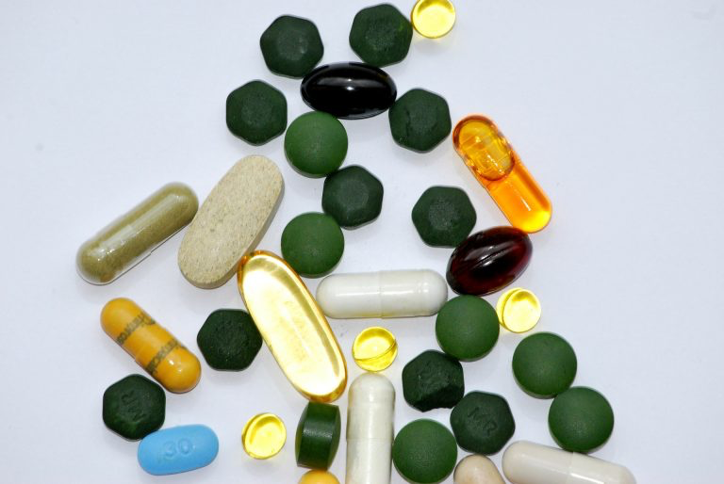
Video: Synthetic Vitamin Formulas are Killing Americans, but FOOD Vitamins Build Health​

Most vitamin/supplements sold are not derived from real food – even if labeled “natural”.
Many are synthetically produced with processed petroleum/coal tar derivatives, chemically altered sugars, industrially processed fish oils, and other chemicals (such as formaldehyde).

Synthetic vitamins were originally developed because they are less expensive to produce.
However, they are not in the same chemical or structural form as real vitamins are in foods; thus they are not natural for the human body. True natural food vitamins are superior to synthetic ones and are generally better absorbed and retained by the body. Isolated, non-food vitamins (like ascorbic acid vs. vitamin C), even when not chemically different are only fractionated incomplete nutrients.

*For more in-depth information on this topic, ingredients, definitions, labeling, common misconceptions, and more, please refer to the website’s videos and articles.

Doctor’s Food Research products are available through licensed Healthcare Professionals only. I can place orders for you or you can order through “my online store” as my patient: https://jperry.foodresearchproducts.com/ Password: goodfood
*Please avoid purchasing supplements from Amazon.

If you would like guidance selecting the right products, feel free to contact me.

Jennifer Perry, LAc, MSOM
(808) 256-1035


*Some of this content was reproduced with permission from Doctor’s Food Research. March 26, 2026

